**SUPPLEMENTARY FIGURE S11: Policy Impact prioritisation matrix**

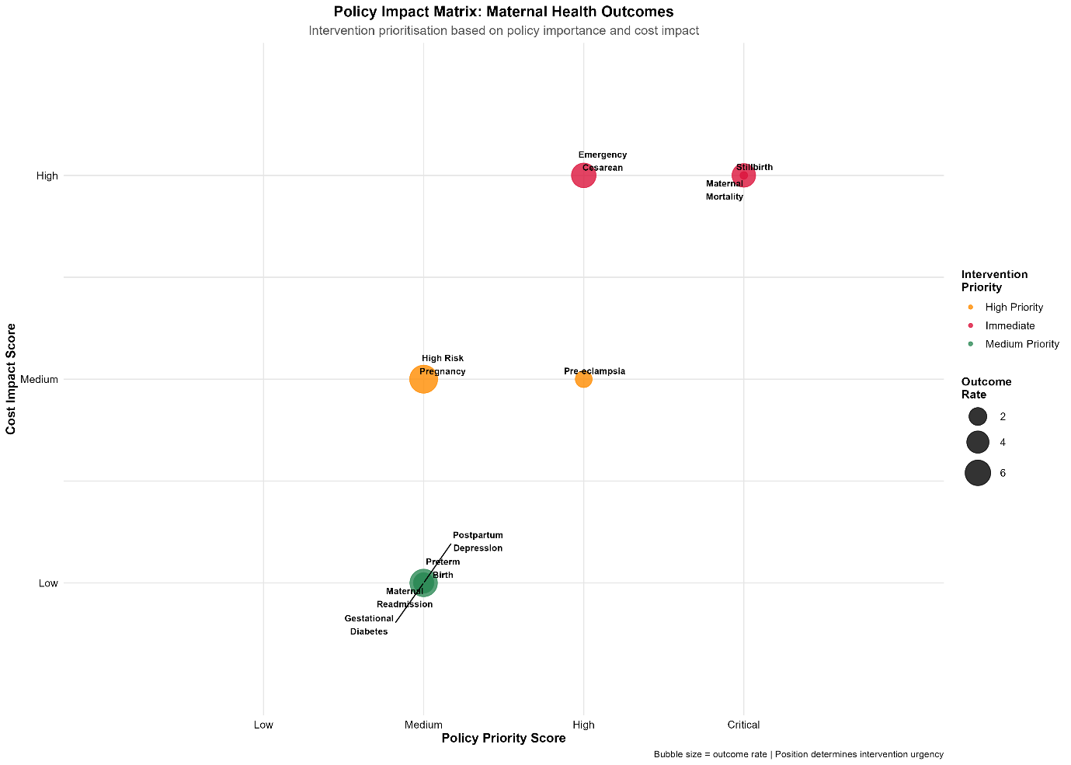

Policy impact matrix for maternal health intervention prioritisation based on policy importance (x-axis) and cost impact (y-axis). Bubble size represents outcome prevalence. Maternal mortality and stillbirth positioned as critical/high priority requiring immediate intervention despite high cost impact. Gestational diabetes and other conditions positioned as medium priority enaling strategic resource allocation decisions.